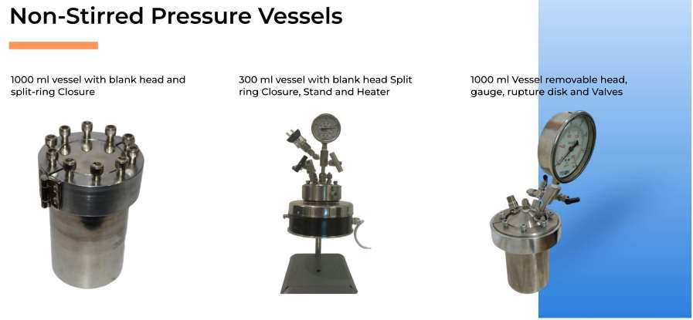

Many of these non-stirred vessels are offered with a blank head with no port or fittings. These can be supplied with PTFE liner and cap to be used as hydro-thermal vessel.
These should be considered only as a starting point for custom built vessels as they do not include a safety rupture disc
Users who take delivery of vessels without safety relief devices installed must also take the responsibility for installing adequate protective devices before the vessel is placed in service. User must check the vapor pressure at operating temperature to ensure that operating conditions are within safety limits.

Model number NS | 1323 | 1346 | 2520 | 2540 | 3045 | 4050 | 40100
Size ml | 50 | 100 | 160 | 300 | 500 | 1000 | 2000
Maximum pressure | 3000 psig (200 bar)
Maximum Temperature | 350 Deg Centigrade
Temperature Sensor | Type K Thermocouple
Vessel Internal Dia. mm | 34 | 34 | 64 | 64 | 76 | 100 | 100
Vessel Internal Depth mm | 57 | 115 | 50 | 100 | 115 | 130 | 270
Closure | Split ring with compression bolts, PTFE gasket
Valve | Swagelok 1/8” NPT, outlet 0.25 inch tube adaptor Gas inlet, liquid  sampling, gas vent
Pressure Gauge | 0~3000 psig/200 bar, 100 mm Dia.

PTFE LINED DIGESTION VESSEL

Model Number | TD1020 | TD1322 | TD1345 | TD2234 | TD2543 | TD2543 | TD4057
Size mL | 23 | 50 | 100 | 200 | 350 | 500 | 1000
Maximum Pressure |  | 1800 psig (120 Bar)
Maximum Temperature |  | 200 Deg. Centigrade
Closure | Screw Cap | Screw Cap | Screw Cap | Screw Cap | Screw Cap | Screw Cap | Split ring
Closure OD mm | 64 | 80 | 80 | 100 | 110 | 110 | 155
Vessel Height mm | 115 | 117.5 | 172.5 | 147.5 | 182.5 |  | 218
Vessel Outer Dia. mm | 45 | 55 | 55 | 75 | 88 | 88 | 126
Vessel Internal Dia mm | 34 | 45 | 45 | 65 | 75 | 75 | 110
PTFE Liner Internal Dia | 24 | 35 | 35 | 55 | 65 | 65 | 100
PTFE Liner Depth mm | 55 | 55 | 110 | 85 | 110 |  | 145
O Ring AS568 | 118  ID 7/8” | 124  ID 1.25” | 124  ID 1.25” | 136  2” 3/32” | 142  2-3/8” | 142  CS 0.103” | 154  3.75”
PTFE Gasket | Optional
Compression bolts | Six | Six | Six | Six | Six | Six | Ten

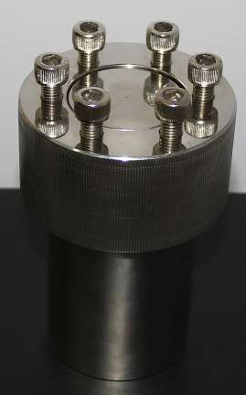 | 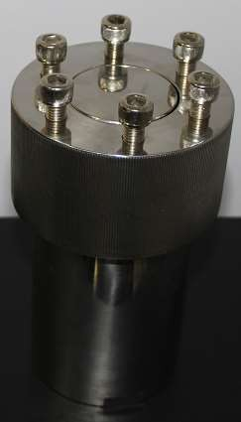 | 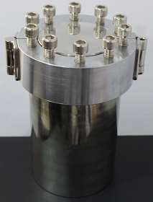
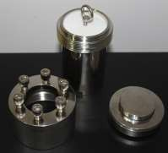 | 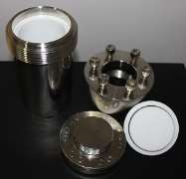 | 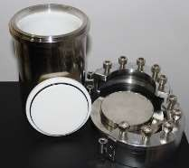

Operating Procedure
There must always be adequate free space above the charge in digestion vessel.

Inorganic samples which do not generate vapors, one can leave 1/3rd of the capacity of the cup as free space.
For organic samples that generate vapors, leave at least 50% as free space for non-oxidizing reactions. For oxidizing reactions leave 75% free space.
The internal forces will sometimes expand the PTFE liner, which makes it difficult to remove from the vessel. A gentle tap on wooded or brass surface will dislodge the liner from the wall. The easy option is to cool the vessel in a refrigerator or freezer to shrink the liner.

Component Description
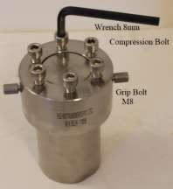
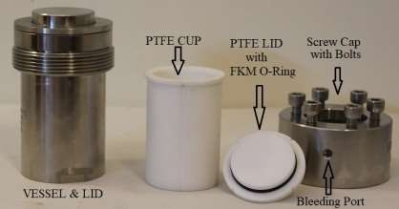

Loading
For test purpose, fill the cup with water to 50% level. Place the vessel in a temperature controlled hot air oven and heat it to desired operating temperature. Do not submerge the vessel in cold water as rapid cooling is not recommended. Cool the vessel to room temperature and check the water level.

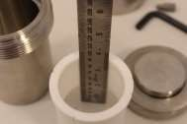 | 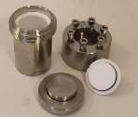 | 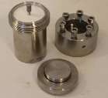 | Add solvent in PTFE cup and  Measure the level. Place PTFE cup in vessel.  Cover the PTFE cup with lid, using M6 bolt

Safety
Most common cause of failure is due to high pressure.
The vessel is placed in hot air oven for extended duration. In case of control failure, the oven temperature can rise to its maximum level, resulting in over pressure

The vessel is over loaded to 80% level with oxidizing reactants. This will cause vapor build up, resulting increased pressure.

In both cases, the pressure build up is gradual, as hydrothermal condition can not cause internal ignition or fire.

To avoid bursting of vessel in hot air oven, two bleeding ports are provided. The vapors will leak from Lid/O- Ring; will gradually emit out from bleeding port.
This prevents bursting of pressure vessel or rupture disc, which results in sudden release.

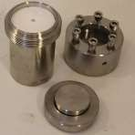 | 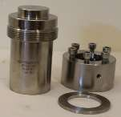 | 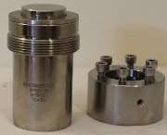 | 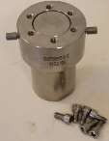
Remove M6 bolt from  PTFE Cap | Place SS lid on vessel | Place compression ring on  Lid | Tighten screw cap  on vessel.

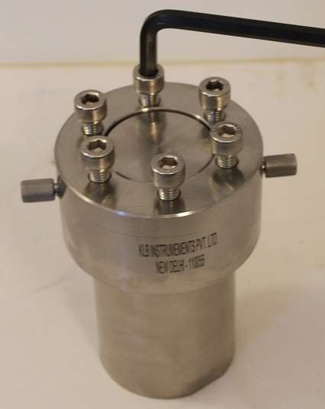
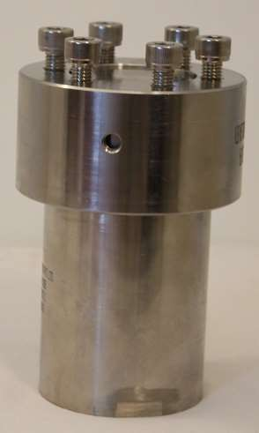

Remove M8 Grip bolts from bleeding port and heat in hot air oven
Mount six compression bolts and gently tighten these with 8mm Hex wrench

Additional Features
The digestor can also be used as SS316 hydrothermal vessel without PTFE cup and O-Ring
The LID is provided with groove to use PTFE gasket.
This gasket is not used when PTFE lid and O ring are used.
The PTFE gasket will provide pressure sealing
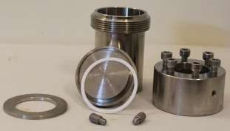

 |  | 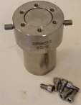 | Place SS lid on vessel  Place compression ring on Lid and tighten screw cap  on vessel.

Mount six compression bolts and tighten these with 8mm Hex 20 ft-Lb wrench | Remove M8 Grip bolts from  bleeding port and heat in hot air oven

Vessel Heaters and Stand for Non-Stirred Reactor

Electric Heaters are most popular choice to heat vessel. These are ceramic band heaters enclosed in steel casing. A sensor port is provided to measure heater temperature.
The heater can be provided to accommodate vessel of different diameters form 50 mm to 175 mm

Condition where explosion proof conditions are required, Indo can provide welded jacket to control the operating temperature. Temperature sensor port is provided to measure circulating fluid temperature.

Conditions where oil bath is to be used, Indo can provided vessel stand with mount to hold the pressure vessel.

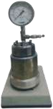
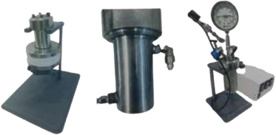

Aluminum block heater with bas
e plate and thermocouple for vessel capacity 50 ml, 100 ml, 300 ml and 600 ml
Four cartridge heater of 250 W each are inserted in machined aluminum block The block is provided with thermal insulation and heart shield
All cables and terminals are completely sealed for heater to be used in flame proof environment.

Compact reactor stand removable head stirred reactor

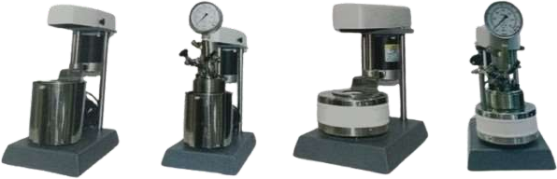

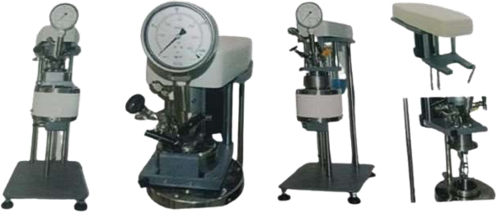

Aluminum Block heater with base plate and thermocouple for vessel capacity 50 ml, 100 ml, 300 ml and 600 ml
Four Cartridge heater of 250 W each are inserted in machined aluminum block. The block is provided with provide with thermal insulation and heat shield.
All cables and terminals are completely sealed for heater to be used in flame proof environment

Photos of 50/100 ml reactor

